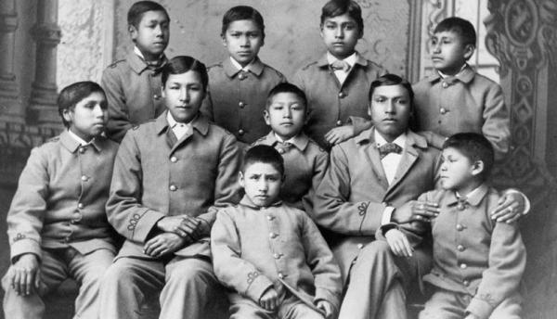
A group of Omaha Indian boys in their cadet uniforms at the militaristic Carlisle School, circa 1880

BIA's Impact on Indian Education Is an Education in Bad Education
Darek Hunt
1/30/12
The forerunner of the Bureau of Indian Affairs (BIA) was created by the U.S. federal government in 1824 to handle all matters relating to American Indians. From its inception, the ultimate goal of what ultimately became the BIA was not to protect Indians, but to assimilate them into white society. One major tool of that assimilation was education.
Secretary of War John C. Calhoun created the Office of Indian Affairs under the guidance of the Department of War. By 1829, the Office of Indian Affairs was sanctioned by Congress and by 1947 it officially became known as the Bureau of Indian Affairs.
Since there was little oversight of the BIA in its early years, greed, corruption and politics shaped federal policy in favor of the encroaching white immigrants and to the detriment of Natives trying to preserve their lands and culture. The early mandate of the BIA was to handle treaties for the government, but in reality BIA representatives acted more as agents for the whites by negotiating treaties that were harmful for Natives. A leading exemplar of this exploitation was Andrew Jackson. Prior to his election to the presidency in 1828, Jackson was a strong political force in the southeastern United States. Utilizing his connections in the federal government, he was able to get vital information about Indian lands from the General Land Office, which worked with the Office of Indian Affairs. By working with family members who were given government jobs, Jackson bought up Indian lands cheaply. According to the author Anthony F. C. Wallace in The Long, Bitter Trail: Andrew Jackson and The Indians, “At the suggestion of his Uncle Andrew, it is said, [John] Coffee made an agreement with the Land Office clerks to receive half of any bribes they took for giving information about land or aiding in its acquisition.” Once he was elected president of the United States, Jackson continued to ruthlessly harass and exploit Natives.
In 1830, President Jackson signed into law the Indian Removal Act and began a process that systematically robbed Natives of their land. Many tribes were exterminated; others were forced to move as far west as Oklahoma. Wallace wrote, “[It] was a disaster that never really ended. The government thereafter pursued the same policy of buying Native lands and relocating Native tribes as the nation moved westward. The Indian territory (as did other reservations) became a vast, poverty-stricken concentration camp for dispossessed Natives, administered by a federal bureaucracy—the Office of Indian Affairs—that largely controlled the local economy, the local police and local schools.”
A major policy shift by the BIA occurred at the end of the Civil War. When that conflict drew to a close in 1865, Congress was tired of war and dismayed by the lack of unity within the country, so it decided Natives would be forced to assimilate to white society and, more important, become good citizens of the United States. That could not happen if the government allowed Natives to retain their lands, their culture and their sovereignty.
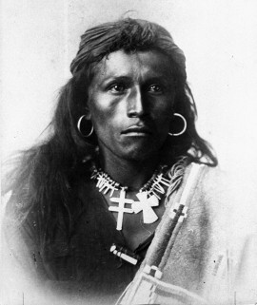

Tom Torlino, Navajo, upon arrival at the Carlisle School in 1887 ...
Tom Torlino
A few of the subsequent U.S. presidents—including Civil War hero Ulysses S. Grant, who took office in 1869—wanted to improve conditions for Indians, but like Jackson, most continued the policy of forcefully removing Natives from their lands. According to the Miller Center of Public Affairs, which specializes in the presidency, policy and U.S. political history, “This approach attempted to move Indians closer to white civilization and ultimately U.S. citizenship by housing them on reservations and helping them become farmers.” This policy not only failed, it created a worse situation for Indians, because most reservation land was not fit for farming.
The education of Natives became a major area of concern for Congress at this time. It set up the first true federal funding for the so-called benefit of Natives. These funds were given to churches that had missionaries teaching and living among Natives, as well as for emerging Indian schools like Carlisle Indian Industrial School and Hampton Institute. This increase in funding was due in part to Congress passing the Indian General Allotment Act of 1887—or Dawes Act, as it is commonly known—which was intended to improve the conditions of Natives and their children. In reality, though, the act took away more Indian lands and took many children from their families. According to Jon Reyhner and Jeanne Eder in their book, American Indian Education: The History, “After tribal members received their allotments, the federal government bought the ‘surplus’
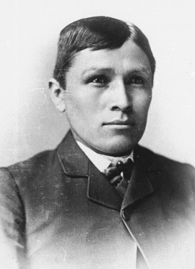

... and how he looked three years later.
TOM TORLINO after
land and resold it to whites, with tribal profits used for ‘education and civilization.’ Over the next four decades the Dawes Act reduced tribal holdings from about 140 million to 50 million acres.”
Prior to 1851, most Indian schools were run by missionaries, and many of the teachers taught in both English and the native language of their pupils. As with most missionaries, the goal was more religious than educational, and while education was a by-product of the process, the complete conversion of a race was the main goal. According to M.T. Garrett and E.F. Pichette, authors of “Red as an Apple: Native American Acculturation and Counseling With or Without Reservation,” published in the Journal of Counseling & Development in 2000, “The federal government wanted to ‘civilize’ Indians, and the churches wanted to ‘Christianize’ them. In short, churches became an instrument for the government.… Whites turned to the power of education to civilize Indian children early in life. Most treaty agreements included provisions for the education of Native youth by establishing church-affiliated schools.” This process wiped out generations of tradition among Natives.
While many missionaries reported much success in these schools, BIA officials were not pleased with the methods being used in them—it was not unusual for missionaries to allow Natives to speak in their native tongues. That practice was soon discontinued, and an English-only policy was mandated.
In 1879, Carlisle Indian Industrial School was created in Carlisle, Pennsylvania under the direction of Richard Henry Pratt, a former Army officer. In a 1977 American Indian Law Review article, “The Evolution of the Termination Policy,” Charles Wilkinson and Eric Biggs give a brief insight into Pratt’s opinion on Indians; they recount that he once stated that “‘a great general has said that the only good Indian is a dead one. I agree with the sentiment, but only in this: that all the Indian there is in the race should be dead. Kill the Indian in him and save the man.’?”
Pratt’s strategy was straightforward: take children away from their parents and reprogram them under the auspices of the government. Natives who attended this type of school endured daily punishment for speaking, writing or even acting in an Indian fashion. The typical day for a boarding school student was spent learning in the morning and the second half of the day was doing manual labor, which would help them once they finished school.
The goal of schools like Carlisle, Hampton Institute and the Phoenix Indian School was to make Natives dress, speak and act like whites. According to Peter Farb in his book, Man’s Rise to Civilization: The Cultural Ascent of the Indians of North America, “The children usually were kept at boarding school for eight years, during which time they were not permitted to see their parents, relatives, or friends. Anything Indian—dress, language, religious practices, even outlook on life…was uncompromisingly prohibited.”
Carlisle’s Indian school became a model for government boarding school across the country, and while some of its practices would
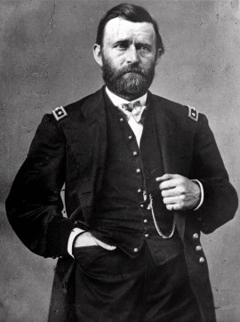

Grant was one of the few 19th century presidents sympathetic to Indians.
Ulysses S. Grant
never be used in public schools, the BIA endorsed the model. According to the Archaeological Institute of America, “A multitude of rules controlled every aspect of daily life. Military discipline was imposed, with boys and girls organized into army-like units and drilled in elaborate marching routines [a practice that continued into the 1930s].” The goal of the military structure was to strip down the Native to his or her core. The boarding schools had to completely erase everything Native children had learned. The schools had to assimilate them completely in American culture.
In “Archaeology of the Phoenix Indian School,” Owen Lindauer writes that Harwood Hall, the head of the Phoenix Indian School, was enthusiastic about this model for educating Natives. In 1897, Hall wrote to the commissioner of Indian Affairs, “Too much praise can not be given to the merits of military organization, drill and routine in connection with the discipline of the school; every good end is obtained thereby. It teaches patriotism, obedience, courage, courtesy, promptness and consistency; besides, in my opinion, it outranks any other plan or system in producing and developing every good moral, mental, and physical quality of the pupil.” This wasn’t just the attitude of one boarding school superintendent—it was a concept supported at multiple schools and by the BIA itself. After the success of the military-style education practiced at Carlisle, Congress expanded the model and funded 23 more schools.
Again, the goal was assimilation, not education. In this system, Natives could never become equals with their white counterparts and schooling was just another way the government could control the Indians. According to one source, “Over the 24 years of Pratt’s direction, Carlisle graduated only 158 students.”
From the 1890s to 1900, more schools were built, but now they were closer to reservations and parents had to agree to send their children to these schools. By 1900, there were approximately 25 federally funded off-reservation boarding schools in the United States. David Wallace Adams, in “Fundamental Considerations: The Deep Meaning of Native American Schooling” for the Harvard Educational Review in 1988, wrote that the BIA was ordered to withhold food, clothing and other resources to pressure parents into sending their children to school. “[Between] 1880 and 1900 the number of Indian children enrolled in school more than quadrupled, from 4,651 to 21,568, the latter figure representing over one half of all Indian children of school age,” wrote Adams.
The education of Natives opened the door for the federal government to take from the Indians the one thing they had that the government wanted and needed: land. In 1887, the Indian General Allotment Act passed Congress and overnight the Natives watched their lands disappear. The overall goal was to make sure Natives received an allotment of land, became farmers and sent their children to school. However, instead of a boarding school or reservation school, they would attend a public school. Reyhner and Eder report that “contracts required Indian students to be educated alongside white students and to be treated the same way, but this was not always done.… Indian students were often too poor to buy clothes for school and did not speak English well enough to do the required class work.”
The Indian Citizenship Act of 1924 gave Natives full rights as citizens of the United States, although the right to vote would not be fully protected until almost 25 years later. However, even as Natives were given citizenship, many of their children were still kept in the Carlisle-type boarding schools. But change was sweeping through Congress and through the general public concerning the treatment of Natives.
In 1928, a report by the Institute for Government Research for the Secretary of the Interior presented some shocking details on the status of Natives. The report, called The Problem of Indian Administration, is more commonly known as the Meriam Report, a reference to its lead investigator, Lewis Meriam. The report painted a bull’s-eye on the BIA and its shameful policies. Reyhner and Eder summed up some of the major issues: “...a persistent problem of BIA schools remained discipline. While the type and severity of discipline varied from school to school, depending on its superintendent, flogging and other severe forms of punishment continued at some schools.” In addition, many Native students were forced to perform manual labor at their boarding schools.
Some administrators at these schools had little training in education and many were former military officers, in part because the BIA felt military rules were best-suited for the task at hand. The Meriam Report uncovered many abuses—many students died while attending the schools, and many more were mistreated. Some of those deaths were related from overcrowding, in other cases it was lack of food. According to the report, “The boarding schools are crowded materially beyond their capacity.… The toilet facilities have in many cases not been increased proportionately to the increase in pupils, and they are fairly frequently not properly maintained or conveniently located.”
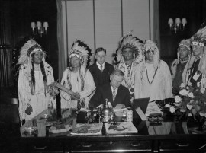

Interior Secretary Ickes signs first constitution issued under Indian Reorganization Act, 1935.
Secretary of Interior Meeting with Native American Tribal Leaders
Even though the Meriam Report was commissioned by the Secretary of the Interior, the BIA ignored its findings.
And providing a useful education was never the goal. According to K. Tsianina Lomawaima and Teresa L. McCarty in To Remain an Indian: Lessons in Democracy From a Century of Native American Education, “Indian school industrial training was designed to prevent Native economic competition in the American workforce, just as low-level academic training precluded aspirations to professional schools or careers.” They quote from an Office of Indian Affairs Education Division publication at the turn of the 20th century, which stressed that “higher education in the sense ordinarily used has no place in the curriculum of Indian schools.” Higher education meant work beyond the sixth grade.
In 1933, John Collier, the new commissioner of Indian Affairs, finally addressed many of the issues flagged in the Meriam Report. One of his major accomplishments was getting the Indian Reorganization Act of 1934 (IRA) brought before Congress. This repealed the Indian General Allotment Act and restored tribal self-government. Reyhner and Eder wrote, “In his testimony to Congress on the IRA, Collier emphasized removing the bureaucratic stranglehold of the BIA from Indian communities and the lack of Indian employees in the Bureau.” Collier pushed for Natives to be allowed to have their culture, religion and language included in the classroom. Randolph C. Downes writes in “A Crusade for Indian Reforms, 1922–1934,” an article published in The Mississippi Valley Historical Review in 1945, that Collier declared, “No interference with Indian religious life or expression will hereby be tolerated. The cultural history of Indians is in all respects to be considered equal to that of any non-Indian group. And it is desirable that Indians be bilingual.… The Indian arts and crafts are to be prized, nourished and honored.”
Based on what they’d learned from the Meriam Report, many members of Congress concluded that the BIA was holding Natives back. The Indian Termination Act of 1953 stripped Natives of their sovereignty and land, terminated all treaties, ended government funding and decreed them full citizens of the United States with the same rights as white Americans. Many members of Congress, the BIA and even the Department of the Interior believed this act would help Natives.
The education of Natives was now the responsibility of the states. Natives were forced into public schools and attendance decreased and Native children suffered, since many could not speak English. The BIA during this period decided to close many boarding schools; forced assimilation continued.
It wasn’t until the early 1970s that the Termination Act of 1953 and its dolorous effects on Natives were reversed.
Natives had been demanding control of their own destiny since the first white settlers started moving onto their lands. When Richard Nixon became president in 1969, they finally had a powerful ally in government. In 1970, Nixon delivered a message to Congress in which he highlighted the government’s poor record of dealing fairly with Natives, and called for significant change. “The time has come to break decisively with the past and to create the conditions for a new era in which the Indian future is determined by Indian acts and Indian decisions,” he said. He had already appointed a Mohawk/Sioux, Louis Rooks Bruce, as the new Commissioner of Indian Affairs. The Indian Education Act of 1972 passed by Congress provided additional funding for public schools with Indian students. Reyhner and Eder cite a 1975 Civil Rights Commission report, which stated: “All public schools with 10 or more Indian students were eligible to receive funding for supplemental programs designed to meet the special needs of Indian students, including the use of culturally relevant and bilingual curriculum materials.” The Office of Indian Education was also created and placed within the Department of Education, and for the first time, parents and tribal elders were giving input on language, materials taught and even who was teaching their children—in 1973, only 188 of 2,800 teachers on the Navajo Reservation were Navajo.
The Self-Determination and Education Assistance Act of 1975 was the legislation that forever changed how Natives interacted with the federal government. It promoted self-governance by tribes and allowed them to contract with federal agencies—such as the BIA and Indian Health Service—to control and operate programs and services formerly administered by those agencies.
There is one more bill that had a huge and positive impact on Indian sovereignty and the quality of education for young Natives, but its impact was indirect. The Civil Rights Act of 1964 was very important for Natives because it ended segregation of public schools. While most Natives were granted full civil rights in 1924 and Natives had already been admitted to white schools, it was the political turmoil of the 1960s that had lasting effects. More and more Natives wanted to make sure they were heard in the political debate. Just as blacks were becoming more militant, Natives believed great activism would help them, and in 1972 activists briefly occupied the Washington, D.C. headquarters of the BIA. This era was the starting point for new tactics that helped end Indian termination policy.
In 1984, a Presidential Commission on Indian Reservation Economies was critical of the BIA for “incompetent” management of trust assets; excessive regulations and “red tape”; “incompetent” technical assistance to tribes; and “deficient” performance of activities such as credit, finance, contracting and procurement. The commission recommended the abolition of the BIA and its replacement with a new agency to be called the Indian Trust Services Administration, which would have granted funds to tribes to contract for their own services. At hearings in 1989, a Special Committee on Investigations of the Senate Select Committee on Indian Affairs probed the allegations against the BIA. The special committee’s investigation led Senator Dennis DeConcini, its chairman, to conclude that “[many] of the federal Indian programs are fraught with corruption and fraud. Most of the others are marred by mismanagement and some by incompetence.”
While tribes have taken on much more responsibility in the educating of their youth, they still have to deal with the BIA for funding and grant requests. It has only been in the past 40 years that the focus has shifted from what the government wants to what the Native community wants and needs. Since the role of the BIA continues to be a major factor regardless of mismanagement and corruption issues, Natives will have to work with them until true self-determination is achieved.

Read more at http://indiancountrytodaymedianetwork.com/2012/01/30/bias-impact-indian-education-education-bad-education-75083

